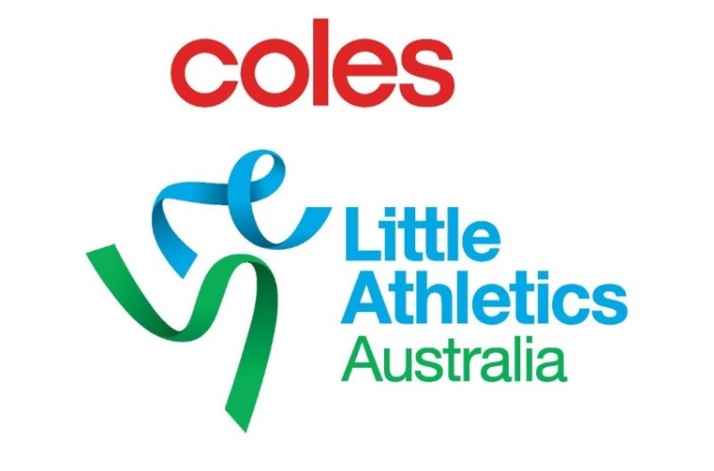

Coles Little Athletics Australia
2019 Roll of Excellence
Nomination Form

Association: ________________________________________________________

Name of Nominee: __________________________________________________

Nominee contact details:

- Mobile: __________________________________________________
- Email: ___________________________________________________
- Agent or Manager: _________________________________________

Category (please highlight)

Track & Field
Sportsperson
Volunteers
Achievers

Nominations from centres or individuals must be submitted via your State Association. States will then forward on to the Coles LAA CEO no later than 5pm (AEST) 28th June 2019.

Photos/Videos: Please ensure to attach photo(s) and any relevant video(s) of the nominee, alternatively past the photos below.

Please fill in as much information as possible under the following sections

Little Athletics career:
(Year started little athletics, centre, state/national awards, records, achievements)

Post Little Athletics Career: (continuation in athletics/another sport, achievements, awards)

Any other relevant information:

